SD Card Integration

In this document, we will connect the SD card breakout to our Arduino by means of a standard SPI connection. We will then to insert an SD card, write some text a file on that SD card, and finally insert the SD card into our computer’s card reader so that we can view the text file on our computer.

Part 1 Wiring
The SD Card communicates over an interface called Serial Peripheral Interface or SPI. The SPI bus has three lines for data going from the Arduino to the SD card (green), from the SD card to the Arduion (blue), a shared clock line to ensure synchronous operations (Yellow), and a Chip Select so the Arudino can specify which device on the SPI bus it wants to talk to (Orange). Of course, the device also requires a 3.3V power line (Red) and a ground line (Black).
Wire your SD card to the Arduino as shown in the schematic below. Note that that top pin (CD) on the SD card is not used in this configuration. Also remember that your prototyping boards provide power and ground rails, so you don’t need to bring power and ground all the way back to the pins on the Arduino to connect power and ground.
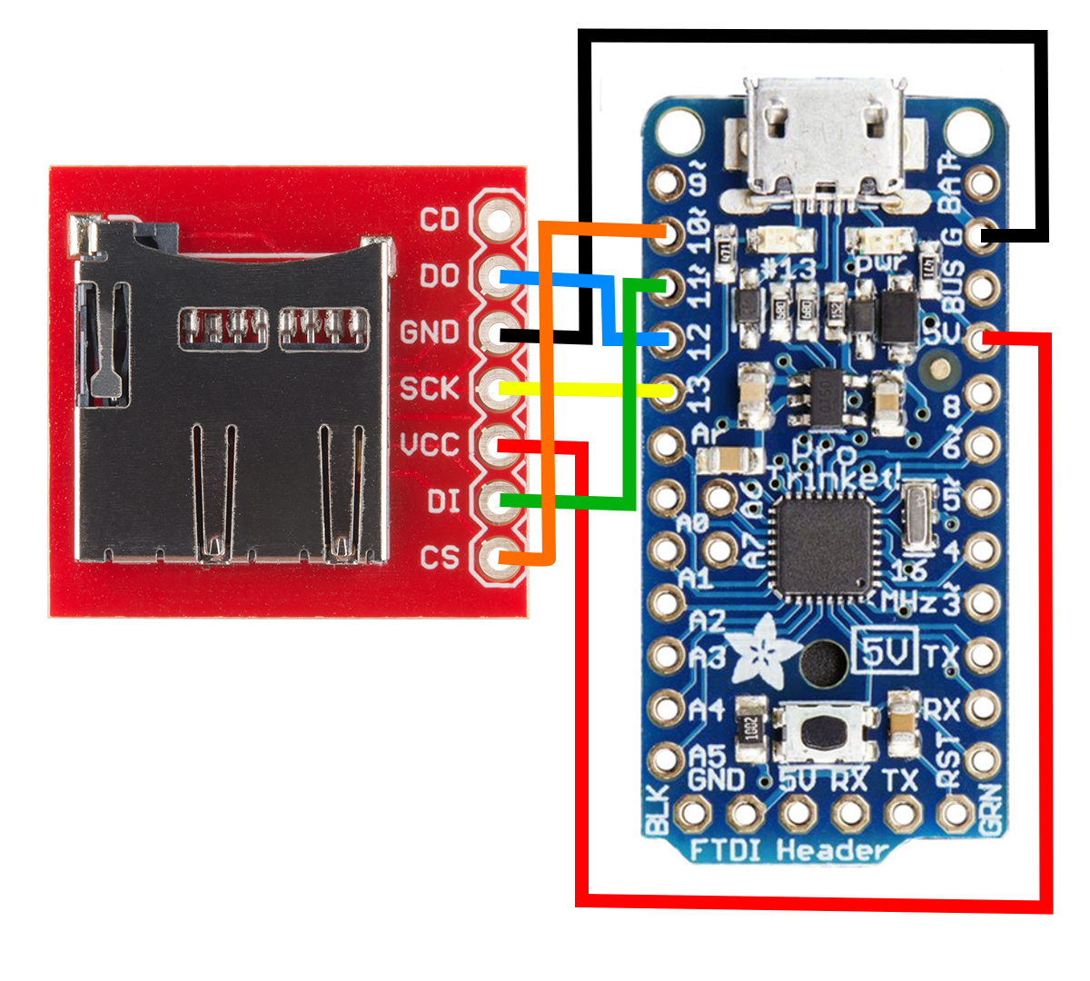

Part 2 SD Card Format
Depending on where you bought your SD card and whether or not it’s brand new, you may or may not have it formatted in a way that it can be read from and written to by our code. We will, using our Windows 7 computer, format the disk properly as FAT32.

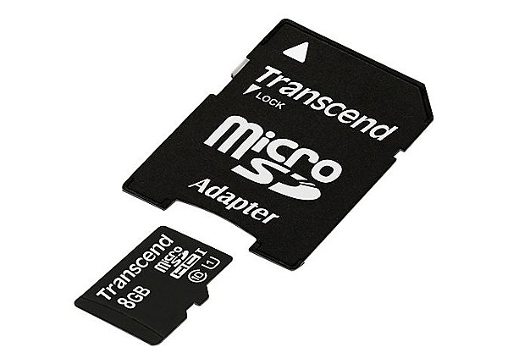
To keep our experiment small, we write to a micro SD card. This is the same type of small form factor storage device you might see in your cell phones or tablets. However, most card readers are not equipped to read a device this small. With your SD card, you will also have received a micro to standard SD adapter as pictures below. This lets your micro SD card fit into your computer’s card reader.

Put the card into your computer’s card reader and it should be recognized by windows. Next, go to Start→ Computer
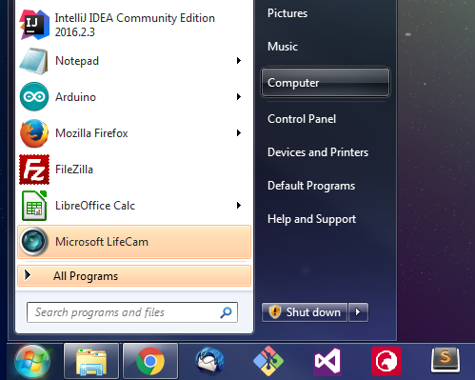

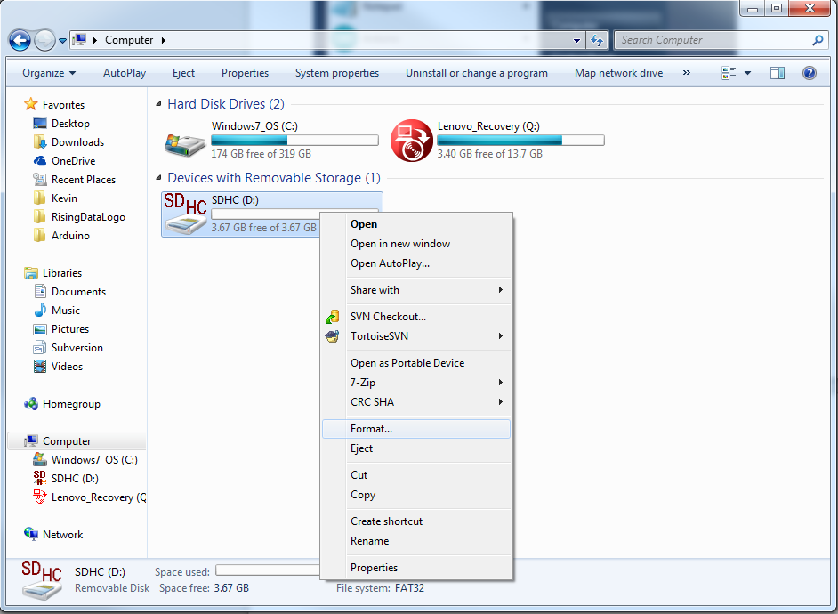
You should see your device listed under ‘Devices and Removable Storage.’ Right click on the device, and select ‘Format’

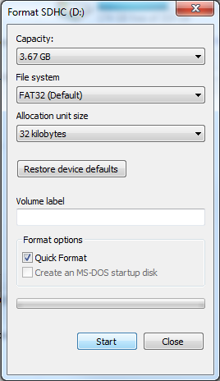
You will be presented with a dialouge window like the one to the right. Make sure the File System shows as FAT32 and then press start. You will be warned (and rightly so) that this process will delete all the information on the drive. If you have any data on this drive, be sure to save it somewhere safe before continuing. When complete, you will get a process complete message. At this point you may remove the SD card from the computer and place it in the SD breakout on your payload.

Part 3 SD Software
Next, open the sketch RisingData/src/SDCard/SDCard.ino. You can upload this sketch as written, then open the serial monitor, and see the phrase ‘Hello World’ being written to the screen every second. This text is also getting written into a text file on the SD card.

